Chapter 2: States of a Process
"Exists a universe inhabited by
an immortal creature
with extraordinary intelligence.

A creature belonging to a species in which
only one unique specimen can exist.

And it spends its life alone,
observing the universe,
And thinking,
throughout eternity.”

Fabhrius.
(excerpt from the book, 'Rainland's Lost Codex')

Introduction

In the previous chapter,
we discussed information processing
and conceptually simplified it as a procedure that utilizes
data and a method.

We also identified the minimal characteristics that a calculating machine should possess to support this process.

In this chapter,
we will delve into the concepts that will help us create
the method
that the machine will use
to find solutions to problems.

These concepts are:

- the states of a process, and
- graph exploration.

By the end of the chapter, we will have all the necessary elements
to conduct the experiment.

States of a Process

Let's say we're playing a game of chess and we want to suspend it for today to continue tomorrow from the exact point where we left off.

To do this,
we should remember
in what "state"
the game was when we suspended it.
For this purpose,
it would be sufficient to list
the position of each piece on the board and who should play next.

This way, we could reconstruct the game,
placing each piece in its position,
and resume the game from the exact point where it was when we suspended it.

We can observe how the game changes state as it evolves.
More specifically, it will change state every time a move is made.

A snapshot of the board
won't show us the complete evolution of the game
from start to finish,
but only the "state" it was in at a particular moment in time.

The game will go through different states
as it progresses from the beginning to the end.

Types of States

Let's revisit the example of summing a list of numbers that we saw in the previous chapter.

Finding the solution has required 3 operations,
3 steps in the calculation process.

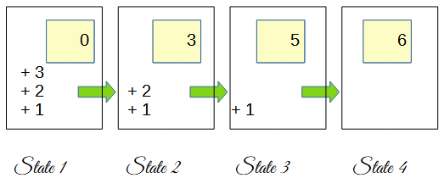

And after each step,
after each addition operation, something has changed in the dataset.
The dataset changes state
every time we perform an operation.

And among the possible states that a process will go through,
we can distinguish three characteristic types:

- The Initial State
- The Final State
- and Intermediate States

The Initial State
Represents the state in which the process was before starting.
It is the starting point of the process.

In the case of a game of chess,
in the initial state,
all the pieces are placed
in their starting positions
and no moves have been made yet.

In the sum of a list of numbers,
in the initial state,
the list of numbers is complete,
and the value of the partial result
is still zero.
No calculation
has been performed yet.

The Final State

Represents the state we aim to achieve.
The moment when the process reaches its resolution and concludes.

In the case of a game of chess,
the final state is reached when
checkmate is delivered.
In the sum of a list of numbers,
the final state is reached when
we obtain the total result.

The Intermediate States
Are all those states that are neither initial nor final states.

In the case of a game of chess,
the game will go through a series of intermediate states
before reaching the final state.

In the example of
summing a list of numbers,
there are 2 intermediate states between
the initial state and the final state.

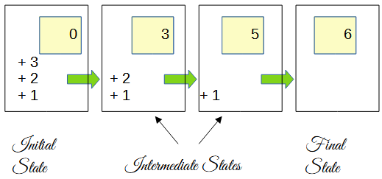

The concept of process states
Graph Exploration
and understanding how a process will change state
every time an operation is performed will help us solve problems.

Along with the idea of states, we will use a structure called a "graph."
I will briefly explain what a graph is and how we will use it.

In mathematics and computer science, a "graph" is an abstract structure
that represents
relationships between objects.
A graph consists of
a set of nodes and
a set of edges
that connect pairs of nodes.

On paper, we represent
a node as a circle and
an edge as a line.

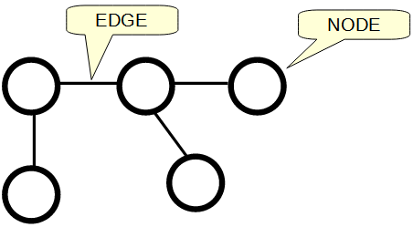

In Practice

Within the nodes, we will place states, one state in each node, and the edges will show us the relationship between a state and the previous one.

Let's look at some examples
with the game of Tic-Tac-Toe.
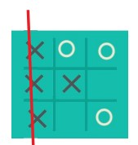

The game starts with an empty board.
Therefore,
the initial state is
a board without pieces;
no moves have been made yet.

We place this initial state
inside a node.



The next state is obtained by making a valid move.
The first player must place a token on the board.

At this moment, the board has 9 empty squares,
and therefore, there are 9 possible valid moves.
Nine possible new states.
We place each of these new states in nodes
and connect them to the parent with edges.

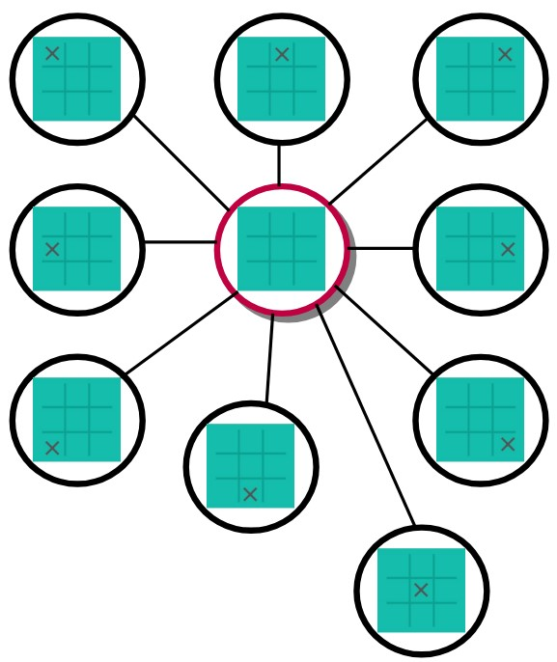

Note that the edges show the relationship from parents to children,
or from ancestors to descendants,
because a state is a consequence of the previous one.

The new state is generated by making a valid move from the previous state and therefore cannot be a consequence of other states,
it can only be a descendant of the parent state.

The valid moves
from the initial state are nine,
and they have generated
nine new states.
The next step is
to make all the valid moves
from these new states,
adding new nodes to the graph.

I will show it graphically for one of them.

We will continue developing the graph
until all possible states have been included.

This will show us
all the possibilities the game has,
and all the possible final states.
Since there are many ways
to win the game.

It will also show us
the paths
formed by nodes and edges
that lead from the initial state
to any of the final states.

In the following diagram, we see only one of the paths
from the initial state to one of the possible final states.

In the drawing, only the isolated path is shown, but as you can imagine,
to find this path, a large number of other states, nodes, and edges
have been generated.

Specifically, in this game of Tic-Tac-Toe, being a simple example,
there are 9*8*7*6*5*4*3*2 possible states.
That is 362,880 possible states.

The important thing here is for you to see
how the concept of states can be used along with a graph
to find the solution to a problem.
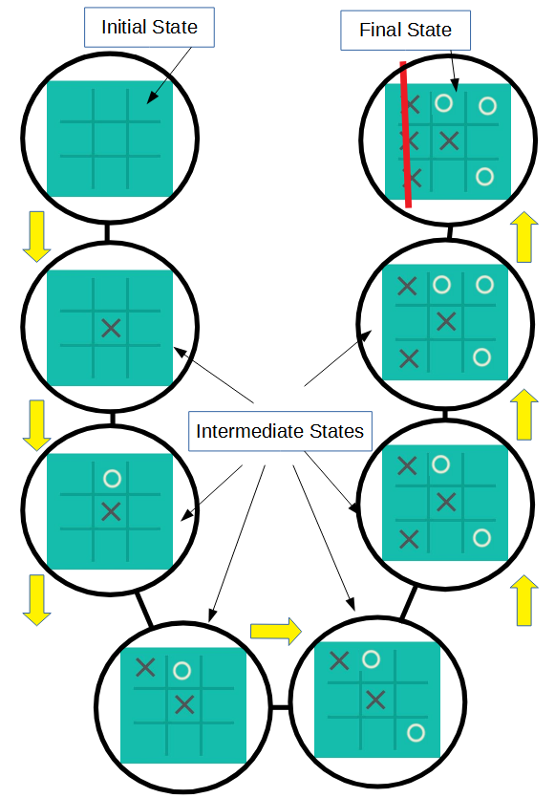

If we apply this technique to the game of chess,
the graph will be notably more complex than that of Tic-Tac-Toe.

The number of states a game of chess could go through
is approximately 10 to the power of 120,
something like a one followed by 120 zeros.

But if we could generate all the states and create a graph with them,
then we would have a map that shows us all possible paths between states leading from the initial state to a final state.

With this map, we could search for the state we are in now, and from there, see which move puts us on the path to one of the final states.

And we would always know which piece to move next to win the game.

Simply by following the path.

However, the graph for the game of chess is too large to fit entirely in a computer's memory, and therefore, although computers use this technique to play chess, they use it in combination with other techniques that allow them to leverage smaller-sized graphs.

Computer memory is limited, and many real-world problems could require more memory than is available, a characteristic that can make many of these problems insurmountable.
We will discuss this limitation of computers further later on.

Very well.
We have talked about process states,
we have talked about graphs,
and how it's possible to find answers by combining graphs with states.

We have everything now.
With these ideas in mind,
we are ready to start building the computer
and carry out the experiment.

